Name:  Class: | ____________________________________  ________________ | Date:_________
 | Year 9 Mathematics 2018  /21  35 minutes  Investigation  Trigonometry  Validation  You will need: Collaborative component, calculator, ruler

- Complete the table below using your COLLABORATIVE component. (complete the ‘ratios’ column as a decimal value). [4 marks]

 |  |  |  |  | RATIOS
Triangle | Angle | OPP | ADJ | HYP | OPP $÷$ HYP | ADJ $÷$ HYP | OPP $÷$ ADJ
2
4
6
8
 |  |  |  | MEAN

- Use the 4 triangles below to measure the lengths of each side and complete the table (complete the ‘ratios’ column as a decimal value). [5 marks]

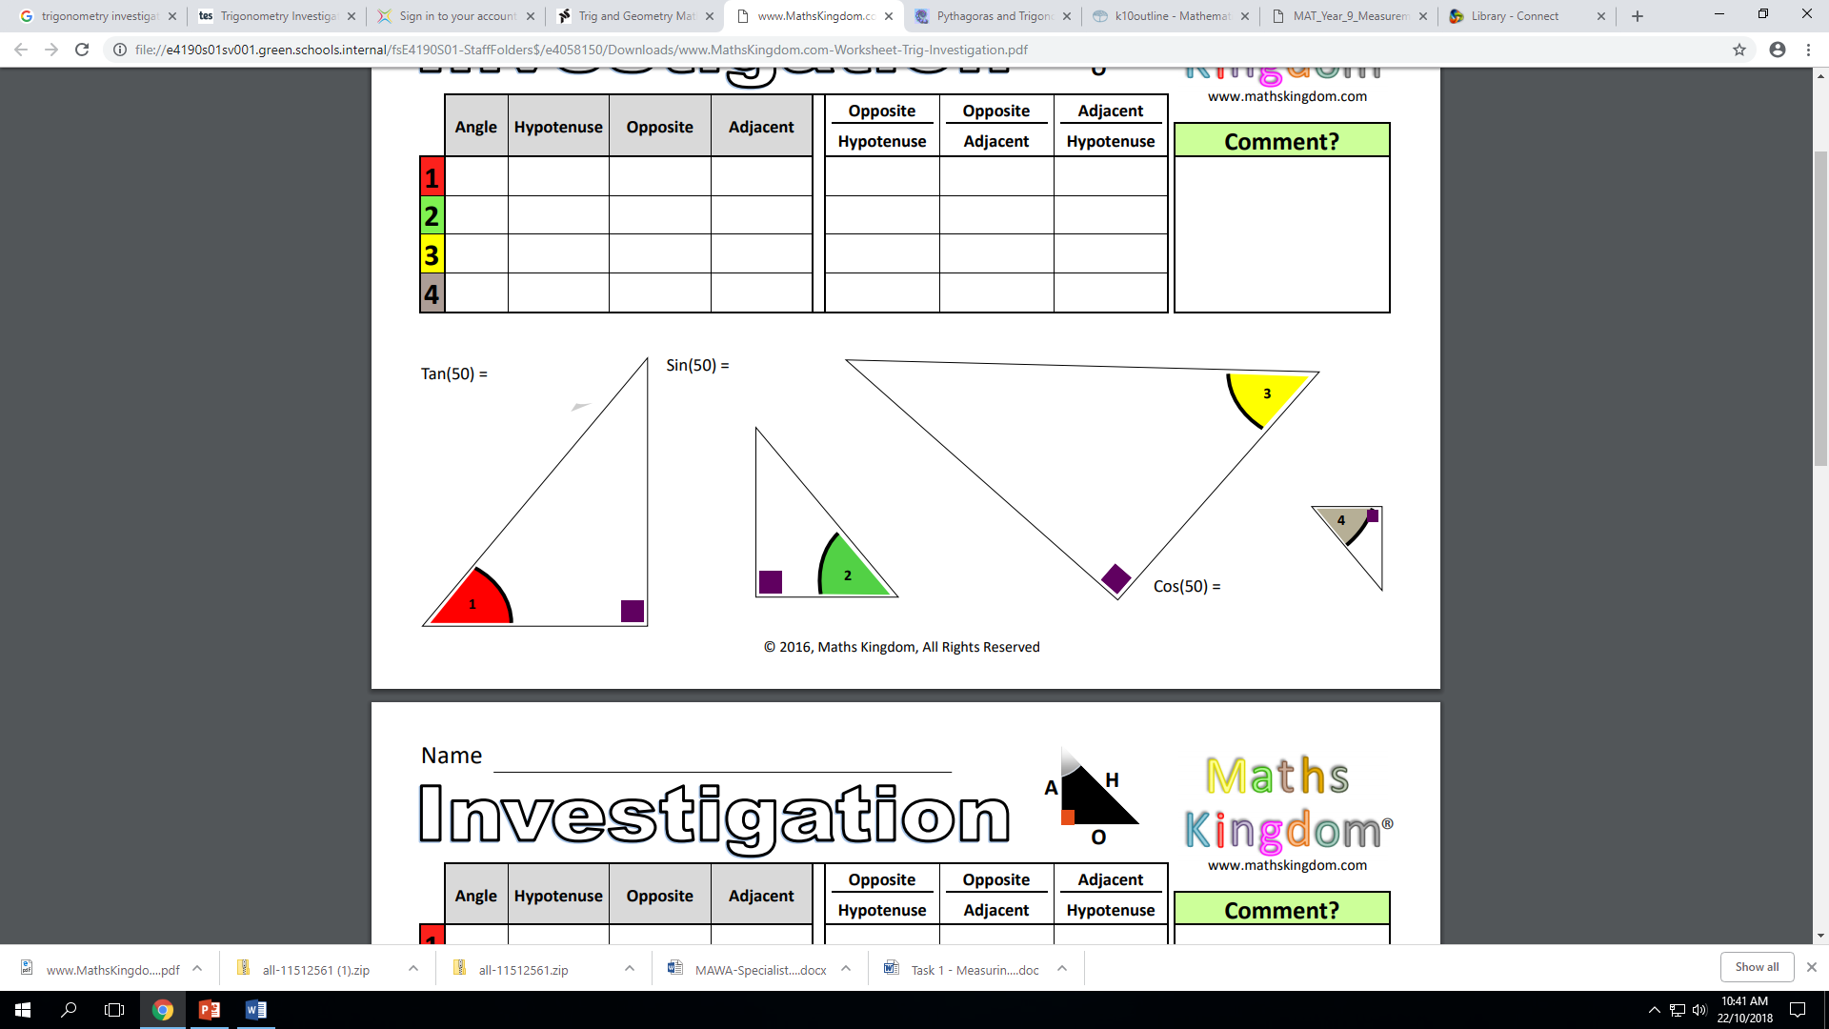



 |  |  |  |  | RATIOS
Triangle | Angle | OPP | ADJ | HYP | OPP $÷$ HYP | ADJ $÷$ HYP | OPP $÷$ ADJ
1 | 50$°$
2 | 50$°$
3 | 50$°$
4 | 50$°$
 |  |  |  | MEAN

- Use a calculator to find; [3 marks]

- $sin 50°$ =

- $cos 50°$ =

- $tan 50°$ =

- Comment on how the values relate between question 2 and 3? [1 mark]

- Explain the relationship you’ve noticed in question 4, in terms of ratios for each angle size. [4 marks]

[You can use a diagram to explain and include words such as; ratio, similar, angles, sides, hypotenuse, adjacent and opposite]

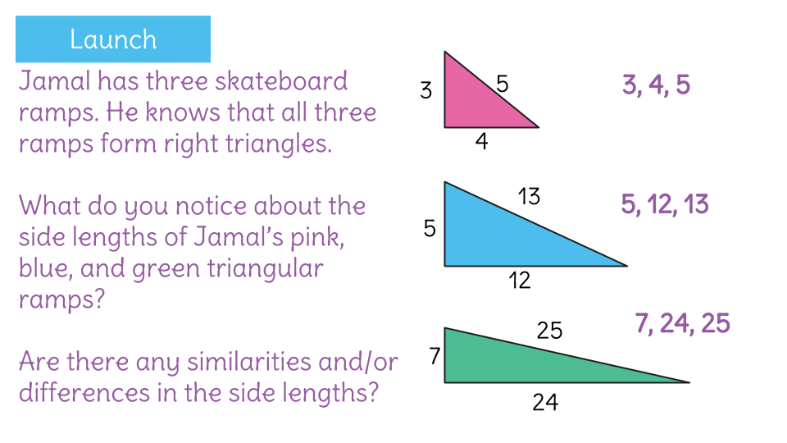
- Given the two Pythagorean triads, state the sine ratio for the indicated angle. [2 marks]


$$θ$$

$$θ$$

- Make a comment on the two triangles above in relation to similarity.
[2 marks]

